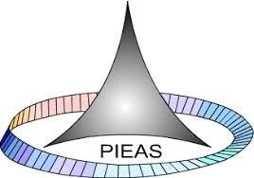

PAKISTAN INSTITUTE OF ENGINEERING AND APPLIED SCIENCES

***Computing Fundamentals & Programming***

**FALL 2020**

Laboratory Exercise-04

Name: Umar Shifaqat

Department: DPAM

Roll No. BS-20-GB-100864

Date: OCT 21, 2020

TASK 1

**Write a C program to read temperature in centigrade and display a suitable message.**

# INPUT

#include<stdio.h> int main()

{

int temperature; printf("\t\t\"This Program Displays Weather Condition in Your Area\""); printf("\n\n\n Please enter the temperature in Degree Centigrades : "); scanf("%d",&temperature);

(temperature<0) ? printf("\"This is Freezing Weather."):

(temperature<=10)? printf("\"This is Very Cold Weather."):

(temperature<=20)? printf("\"This is Cold Weather"):

(temperature<=30)? printf("\"This is Normal Temperature."):

(temperature<=40)? printf("\"The Weather is Hot."): printf("\"The Weather is Very Hot."); printf("\"\n\n\n\t\tThanks for using our program.");

getchar(); getchar(); getchar(); return 0;

}

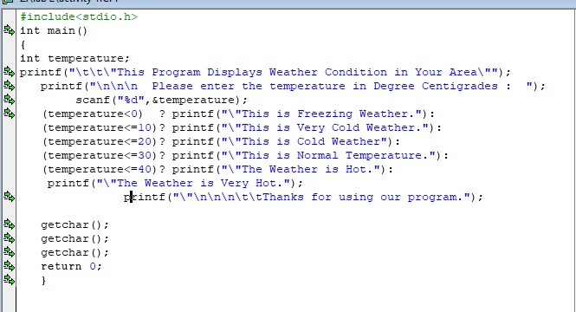

*Figure : 1.1*

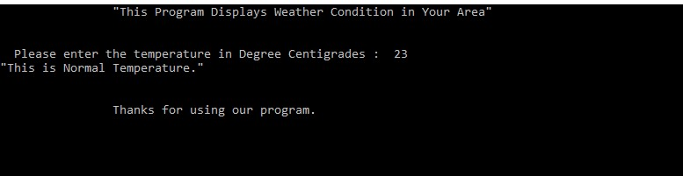

*Figure : 1.2*

# TASK 2

**WRITE A C PROGRAM TO GET THREE INTEGERS FROM USER AND FIND THE SMALLEST NUMBER AMONG THREE**

**NUMBERS**

**INPUT**

#include<stdio.h> int main()

{

int num_1,num_2,num_3;

printf("Enter the numbers you want to compare : ");

printf("\n\tEnter 1st Number : "); scanf("%d",&num_1); printf("\tEnter 2nd Number : "); scanf("%d",&num_2); printf("\tEnter 3rd Number : "); scanf("%d",&num_3); printf("The Smallest Number is ");

(num_1<num_2 && num_1<num_3) ? printf(" 1st Number = %d ", num_1) : (num_2<num_3 && num_2< num_1) ? printf(" 2nd Number = %d ", num_2) :

printf("3rd Number = %d ", num_3); getchar(); getchar(); getchar(); getchar(); return 0;

}

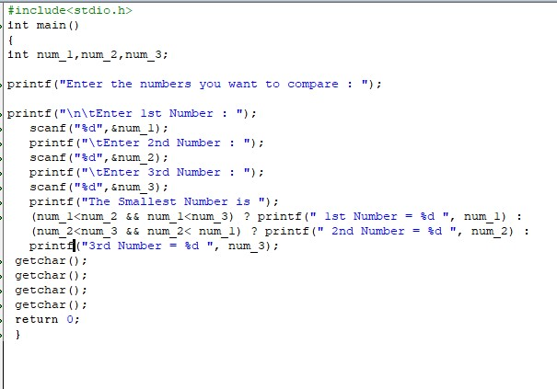

*Figure 2.1*

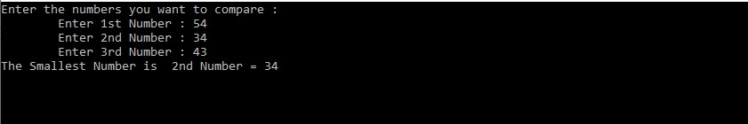

*Figure 2.2*

**TASK 3**

**Write a C program to check sign of given number.**

# INPUT

*#include<stdio.h> int main()*

*{*

*int number;*

*printf("Enter the numbers you want to check : ");*

*printf("\n\t\tNumber = "); scanf("%d",&number);*

*printf("The Given Number is "); (number>0) ? printf(" a Positive Number .") : (number<0) ? printf("a Negative Number .") :*

*printf(" ZERO( Neutral) ."); getchar(); getchar(); getchar(); getchar(); return 0;*

*}*

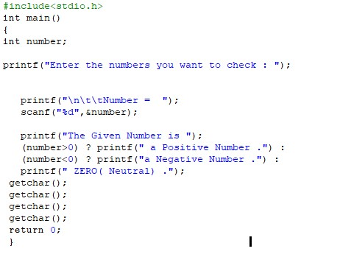

*Figure: 3.1*

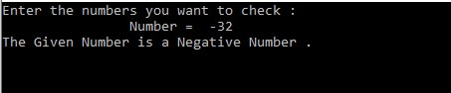

*Figure: 3.2*

# TASK 4

Write a program that lets user enter an integer value between 1 and 10, the program validates the input, if the value entered is between 1 and 10 the program prints the message “Valid Number” and value entered otherwise the program should print message “Invalid Number” and value.

## INPUT

#include<stdio.h> int main()

{

int number;

printf("Enter a number between 1 and 10 : ");

printf("\n\t\tNumber = "); scanf("%d",&number);

(number>=1 && number<=10) ? printf("\tVALID NUMBER ") :

printf("\tINVALID NUMBER ") ; printf("= %d ",number); getchar(); getchar();

getchar(); getchar(); return 0;

}

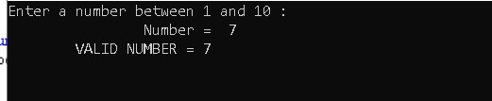 *Figure: 4.1*

## TASK 5

**Write a C program to read the age of a candidate and determine whether it is eligible**

**for casting his/her own vote.**

### INPUT

#include<stdio.h>

int main()

{

int age; printf("Here you can check \"If you are eligible for voting\" ");

printf("\n\tPlease Enter your age. \n\n\t\t AGE = "); scanf("%d", &age);

(age>=18)? printf("You are \"ELIGIBLE\" for Voting."):

printf("You are \"NOT ELIGIBLE\" for Voting");

getchar(); getchar(); getchar(); return 0;

}

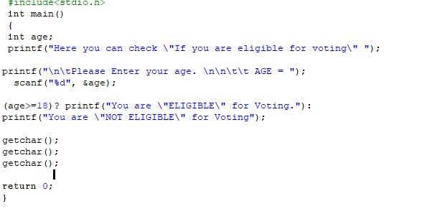

*Figure: 5.1*

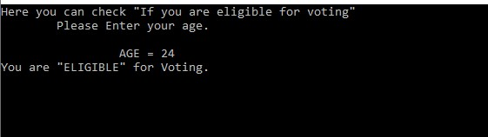

*Figure: 5.2*

**TASK 6**

**Write a program t to check whether the triangle is valid or not if sides are given.**

## INPUT

#include<stdio.h> int main()

{

int side_1,side_2,side_3; printf("Here you can check whther a Triangle is VALID or NOT\n\n");

printf("\tEnter the 1st side : "); scanf("%d",&side_1); printf("\n\tEnter the 2nd side : "); scanf("%d",&side_2); printf("\n\tEnter the 3rd side : "); scanf("%d",&side_3);

(side_1+side_2<=side_3)? printf( "\n\t\tThe Triangle is INVALID."):

(side_2+side_3<=side_1)? printf( "\n\t\tThe Triangle is INVALID."): (side_1+side_3<=side_2)? printf( "n\t\t\The Triangle is INVALID."):

printf("\n\t\tThe Triangle is VALID.");

getchar(); getchar(); getchar(); return 0;

}

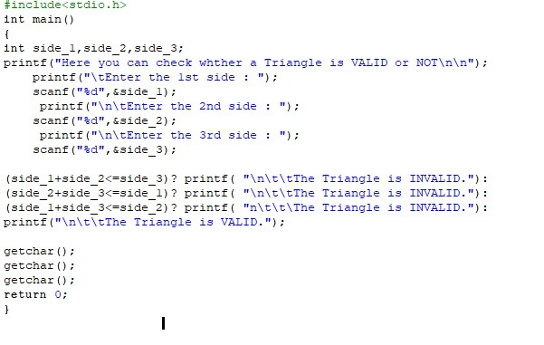

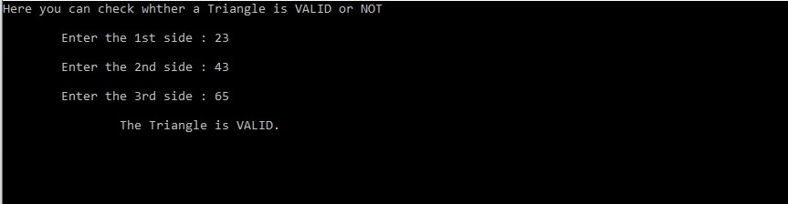

## TASK 7

**Write a program that ask user to a character and check whether a character vowel or**

**consonant**

## INPUT

#include<stdio.h> int main()

{

char character; printf("Here you can check whther a VOWEL or CONSONANT\n\n");

printf("\tEnter the Character : "); scanf("%c",&character);

(character=='a' || character=='e' ||character=='i' ||character=='o' ||character=='u'|| character=='A' ||character=='E' ||character=='I' ||character=='O' ||character=='U')? printf( "\n\t\tThe Charcater is a VOWEL."):

(character>='a' && character<='z')? printf( "\n\t\tThe Charcater is a CONSONANT."): (character>='A' && character<='Z')? printf( "\n\t\tThe Charcater is a CONSONANT."):

printf("\n\t\tThe Character is neither a VOWEL nor a CONSONANT.");

getchar(); getchar(); getchar(); getchar(); getchar(); getchar(); return 0;

}

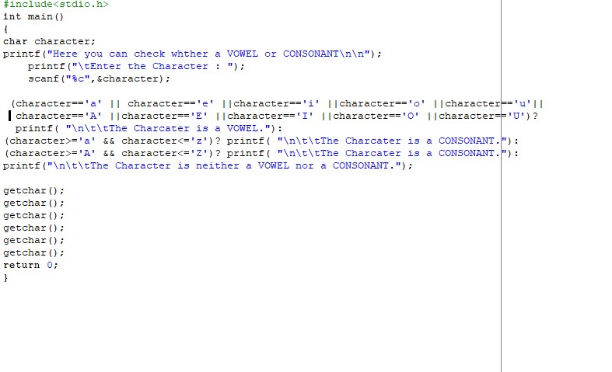

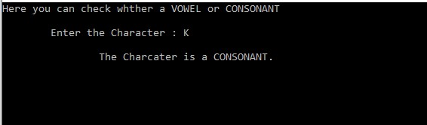

## TASK 8

**Write a program that ask user to enter a two digit number, the program should print this number in words, for example if user enters 12 the program should print twelve, this would be a long task so it is better that you restrict the program to work for numbers between 10 and 35 only.**

## INPUT

#include<stdio.h> int main()

{

int number; printf("You can get a number in WORDS here\n Enter a number between 10 and 35"); printf("\n\n\t\t NUMBER = "); scanf("%d", &number);

printf("\t\t\"");

switch(number)

{

case 10:

printf(" Ten "); break; case 11:

printf(" Eleven "); break; case 12:

printf(" Tweleve "); break; case 13:

printf(" Thirteen "); break; case 14:

printf(" Fourteen "); break; case 15:

printf(" Fifteen "); break; case 16:

printf(" Sixteen "); break; case 17:

printf(" Seventeen "); break;

case 18:

printf(" Eighteen "); break; case 19:

printf(" Ninteen "); break; case 20:

printf(" Twenty "); break; case 21:

printf(" Twenty-one "); break; case 22:

printf(" Twenty-two "); break; case 23:

printf(" Twenty-three "); break; case 24:

printf(" Twenty-four "); break; case 25:

printf(" Twenty-five "); break; case 26:

printf(" Twenty-six "); break; case 27:

printf(" Twenty-seven "); break; case 28:

printf(" Twenty-eight "); break; case 29:

printf(" Twenty-nine "); break; case 30:

printf(" Thirty "); break; case 31:

printf(" Thirty-one "); break; case 32:

printf(" Thirty-two "); break; case 33:

printf(" Thirty-three "); break; case 34:

printf(" Thirty-four "); break; case 35:

printf(" Thirty-five "); break; default :

printf("You have entered wrong number."); break;

}

printf("\""); getchar(); getchar(); getchar(); return 0;

}

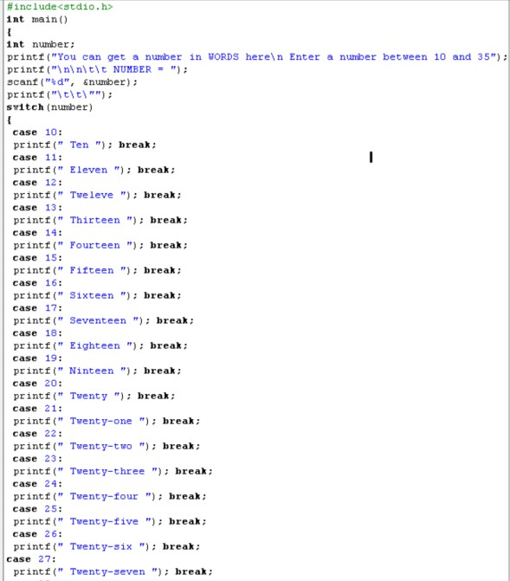

*Figure: 8.1*

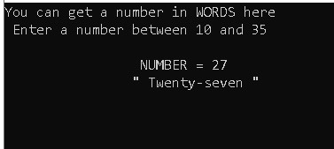

*Figure: 8.2*

## TASK 9

**Write a program that allow user to enter the day of the week as integer value e.g. for Monday the user can enter 1, for Sunday user can enter 7. The program should print the**

**name of the day by using this integer value**

## INPUT

#include<stdio.h> int main()

{

int day;

printf("Day No.1 means Monday\nPlease enter the number of day. \n The number must be any integer value from 1 to 7"); printf("\n\n\t\t NUMBER = "); scanf("%d", &day); printf("\t\t\DAY = \"");

switch(day)

{

case 1: printf(" MONDAY ");

break; case 2: printf(" TUESDAY "); break; case 3: printf(" WEDNESDAY ");

break; case 4: printf(" THURSDAY "); break; case 5: printf(" FRIDAY "); break; case 6: printf(" SATURDAY "); break;

case 7: printf(" SUNDAY "); break;

default :

printf("You have entered wrong number."); break;

}

printf("\""); getchar(); getchar(); getchar();

return 0;

}

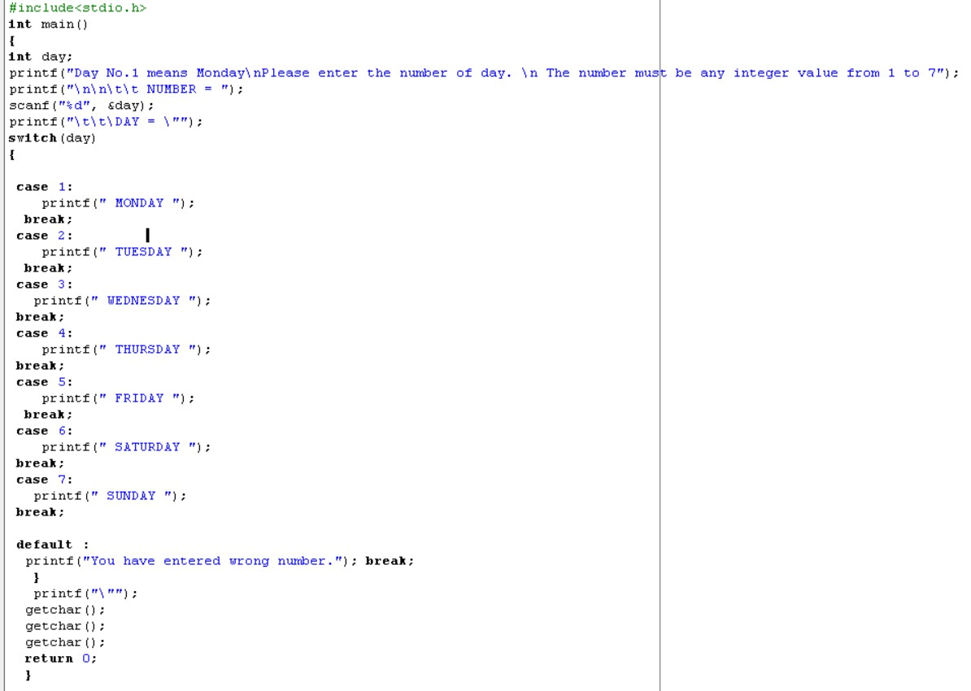

*Figure: 9.1*

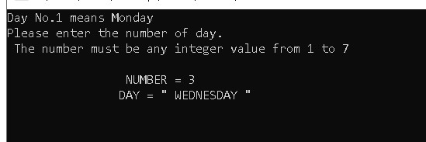

*Figure: 9.2*

## TASK 10

## INPUT

**Develop a calculator that can perform mathematical operations.**

#include<stdio.h> #include<math.h> int main()

{

int a,b,operation; float x;

printf("You can perform a variety of mathematical operations here.\n Enter a specific number to perform an operation.\n ");

printf("\n 1-Addition\n 2-Subtraction\n 3- Multiplication\n 4- Division \n5- Reminder(Mod)\n 6- Power\n 7- Square Root\n 8- Absolute Value");

printf("\n 9- Sin\n 10- Cos\n 11- Tan\n 12- Sec\n 13- Csc\n 14- Cot"); printf("\n\n\n\t Operation= "); scanf("%d",&operation); printf("\n Enter the 1st Number : "); scanf("%d",&a);

printf("\n Enter the 2nd Number : "); scanf("%d",&b);

switch(operation)

{

case 1:

x=a+b; break; case 2:

x=a-b; break; case 3:

x=a*b; break; case 4:

x=a/b; break; case 5:

x=a%b; break; case 6:

x=pow(a,b); break; case 7:

x=sqrt(a); break;

case 8:

( (a>0)? x=a : x=-a ); break; case 9:

x=sin(0.017454*a); break; case 10:

x=cos(0.017454*a); break; case 11:

x=tan(0.017454*a); break; case 12: x=cos(0.017454*a); x=1/x; break; case 13: x=sin(0.017454*x); x=1/x; break; case 14: x=tan(0.017454*a);

x=1/x; break; default :

printf("You have entered wrong number.");

break;

}

printf("\nANSWER = %f ",x); getchar(); getchar(); getchar(); return 0;

}

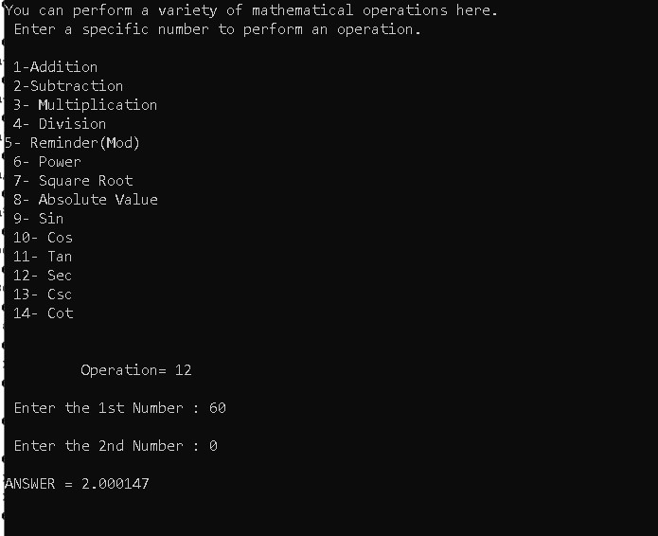

*Figure:10.1*